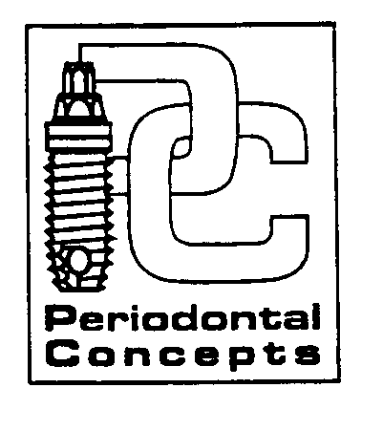

INSTRUCTIONS FOLLOWING PERIODONTAL SURGERY
OSSEOUS SURGERY - BONE GRAFTS – CROWN LENGTHENING – IMPLANTS

READ AND FOLLOW THESE GUIDELINES FOR MAXIMUM COMFORT AND FEWER PROBLEMS

1. BLEEDING: Minor oozing can be expected during the first 24 hours following your surgery. If bleeding continues apply pressure with a wet gauze/napkin for approximately 20-30 minutes. If heavy bleeding continues, contact Dr. Derhalli immediately.

2. SWELLING: Some swelling is NORMAL after surgery. Place an ice pack adjacent to the surgical site(s) over the next 36 hours using the pack 15 minutes on and 15 minutes off (During waking hours).

3. MEDICATIONS: Take your pills as instructed. Do not drink alcoholic drinks or take other medicine without checking with your doctor first. Take pills with FOOD to lower the chance of getting nauseated. If you do become sick (or a rash develops) and it continues, notify Dr. Derhalli immediately.

4. FLUIDS: Drink plenty of fluids for the next few days. DO NOT USE A STRAW!!

5. DIET: Eat whatever feels comfortable, such as soups and soft foods, for a few days following surgery (E.G.- instant breakfast foods, ensure supplement drink). Please avoid chewing on the side of the surgical procedure. Avoid hard or crunchy foods that could traumatize and injure the surgical site.

6. ACTIVITY: Reduce your activities for the next few days. Avoid running or strenuous activity. Please rest following surgery!

7. BRUSHING: A clean mouth heals faster! Exercise caution not to injure the surgical site(s). Avoid brushing or flossing the surgical site until specified by Dr. Derhalli.

8. MOUTHSOAKS: Gently rinse your mouth with warm water after each meal to keep the areas clean. You need not add salt to the water. Use any prescribed mouth rinse as directed.

9. AVOID: Smoking (or tobacco products), alcoholic drinks, peroxide or commercial mouthrinses following surgery.

10. SUTURES: Sutures will/will not dissolve – However an appointment will be made for any packing or residual suture removal.

If you have ANY problems or questions regarding you’re healing contact:
Dr. Munib. Derhalli ( Emergency #360- 241-3664)

Cascade Park
300 SE 120th Ave., Ste. 500 Vancouver, WA 98683
360-254-8151

